CPSC 1030 PROJECT DESIGN

For this project, we are going to create a portfolio website with five pages. The webpages we are going to include are:
Website Description
- The Portfolio/Projects Page:
This is also the homepage for the website and displays all the projects I’ve done.
- The Resume Page:
This page will display my resume.
- The Education Page:
This page will display my education timeline.
- The About Me Page:
This page will contain my brief description.
- The Skills and Work Experience Page:
This page will display all the skills I’ve acquired and my work experiences.
Website Design A

Website Design B

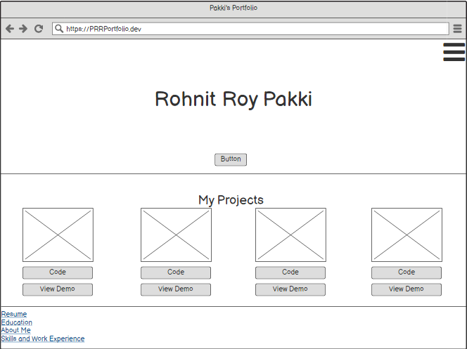
Website Design C
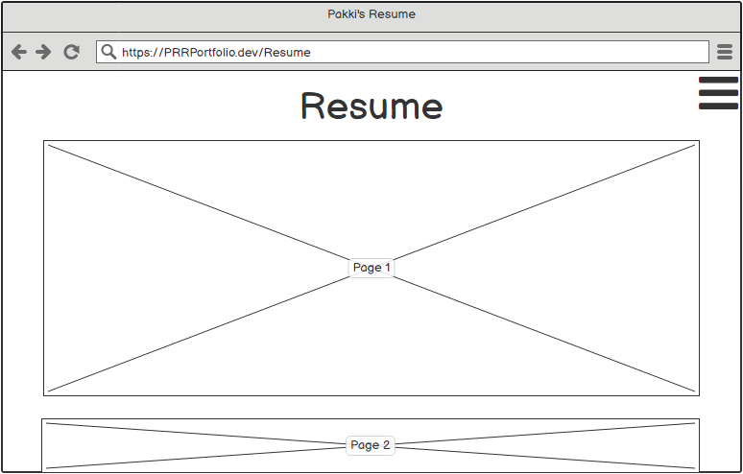
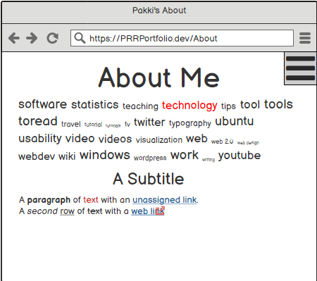

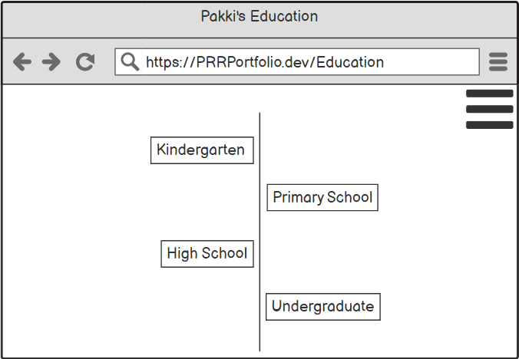

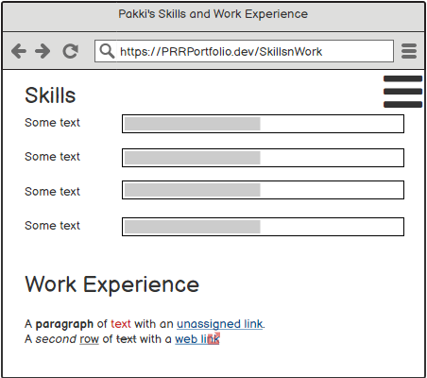

The Colour Pallet and Font Choices are:
Website Design D
Colour Schemes:
- #61892F, #86C232, #222629, #474B4F, #6B6E70
- #182628, #65CCB8, #57BA98, #3B945E, #F2F2F2
- #080F5B, #0D19A3, #15DB95, #F4E4C1, #E4C580
- #19181A, #479761, #CEBC81, #A16E83, #B19F9E
- #C34271, #F070A1, #16FFBD, #12C998, #439F76
Fonts:
- Open Sans
- Roboto Slab
- Montserrat
- League Spartan
- Bebas Neue
- Yellow Tail

